1

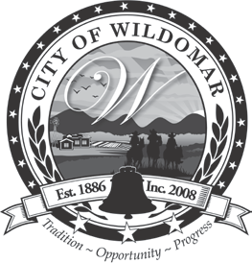 | CITY OF WILDOMAR
 | PUBLIC WORKS/ENGINEERING DEPARTMENT | PLANNING CLEARANCE - GRADING PERMIT
23873 CLINTON KEITH ROAD, SUITE 110
WILDOMAR, CA 92595
 |  | BLD SECTION | 4  FORM NUMBER |  | 2019 CBC CODE CYCLE
 | Ph. (951) 677-7751
 | Fax (951) 698-4163 WWW.CITYOFWILDOMAR.ORG | 03/16/23  EFFECTIVE DATE |  | REVISION DATE
PLANNING CLEARANCE FORM - GRADING PERMIT

Date:

Applicant: Applicant’s Phone #:

Project #: Permit #:

Project Address:

Tract#:

Project Description:

Planning: Approval Date:

